(Approx. 375 words)

Linux Mint 20.1
By Cal Esneault, former President of CCCC and leader of many Open-Source Workshops & SIGs
Cajun Clickers Computer Club
February 2021 issue, CCCC Computer News
www.clickers.org
office (at) clickers.org

Linux Mint is a Linux distribution based on Ubuntu. A long-term support version, Linux Mint 20, was released in June of 2020. An updated version, Mint 20.1, was released on January 8, 2021. This version is known as a “point” release, and only software developed by Linux Mint has features different from Mint 20 (the majority of programs remain tied to the Ubuntu 20.04 LTS repository).

Point releases tend to “refresh” some of the GUI features, and I checked out the Mint 20.1 version with the Cinnamon desktop. Examples of changes that were upgraded to the newest Cinnamon 4.8 desktop and a new set of screen backgrounds.

Mint continues its practice of making an upgrade from the previous LTS as easy and
automated as possible. First, it will alert the user that a new “Update Manager” app is
available. When this is updated, a new entry appears in the “Edit” section that gives a “one-click” upgrade. Be sure to perform all the other regular upgrades before proceeding.
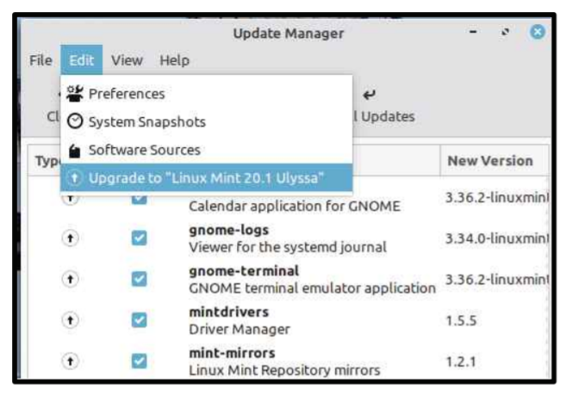
The first steps in the upgrade lead you through a series of pages (see below) where
you click “continue” to progress down a list. First and foremost, you are encouraged to
back up your system in case issues arise.
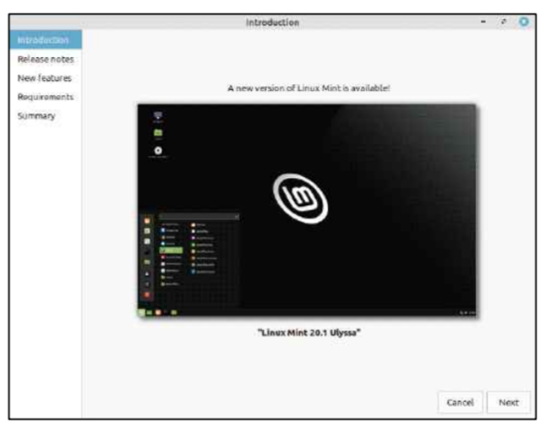
There are sections on “Release Notes” (issues commonly encountered or helpful
configuration hints) and on “New Features” (detailed descriptions of improvements and
changes). You can skip the links if you wish, but I always find it advisable to take a quick glance. If you later need to review them after install, you can find these items on the Mint website.

Before anything is changed, you must check a box stating you understand any potential risks (for this type of release, risks are minimal). The upgrade only takes a few minutes, and a message at the end indicates if it was a success. You have to reboot for the upgrade to take effect.

As usual, this interim upgrade went smoothly on my machine. Although only a few minor
items were changed, it is always good to keep current.

